**Aim:**

To install a C compiler in a Virtual Machine created using VirtualBox / VMware Workstation / Player and to execute simple C programs inside the VM environment.

**Procedure:**

* Create a Virtual Machine in VirtualBox / VMware and install Ubuntu OS.
* Open terminal → update packages using sudo apt update.
* Install GCC compiler with sudo apt install build-essential -y.
* Verify installation using gcc --version.
* Write a simple C program (e.g., test.c).
* Compile using gcc test.c -o test.
* Run program with ./test to display output.

**test.c file:**

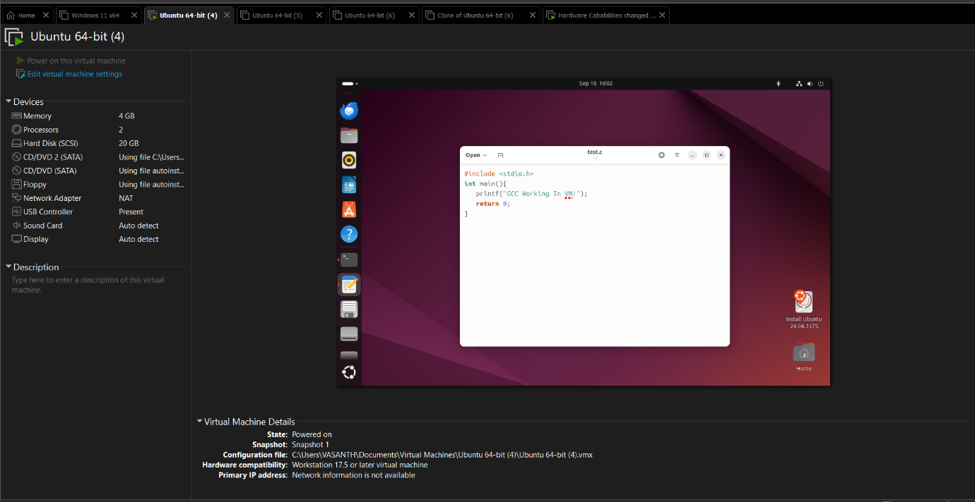

**Output:**

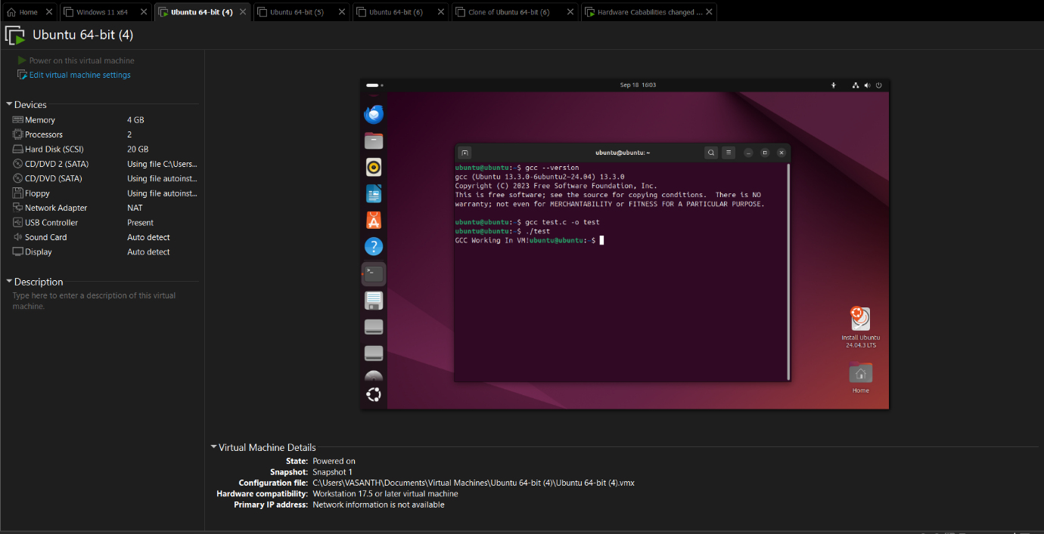

**Result:**

The C compiler was successfully installed in the Virtual Machine created using VirtualBox / VMware. A simple C program was written, compiled, and executed inside the VM environment, demonstrating program execution in an isolated virtualized setup.